Program No.:1
Date :

CALCULATOR PROGRAM

AIM : A Program to develop a Calculator which performs Basic Arithmetic Operations.

PROCEDURE :

activity_basic_op.xml

<?xml version="1.0" encoding="utf-8"?>
<RelativeLayout xmlns:android="http://schemas.android.com/apk/res/android"
xmlns:app="http://schemas.android.com/apk/res-auto"
xmlns:tools="http://schemas.android.com/tools"
android:layout_width="match_parent"
android:layout_height="match_parent"
tools:context=".BasicOp"
android:background="@color/colorAccent">
<TextView
android:id="@+id/t1"
android:layout_width="wrap_content"
android:layout_height="wrap_content"
android:layout_alignParentStart="true"
android:layout_alignParentLeft="true"
android:layout_alignParentTop="true"
android:layout_marginStart="3dp"
android:layout_marginLeft="3dp"
android:layout_marginTop="108dp"
android:text="Enter the 1st No."
android:textColor="@android:color/holo_green_light"
android:textSize="18dp"
android:textStyle="bold|italic"
android:typeface="serif" />
<TextView
android:id="@+id/t2"
android:layout_width="wrap_content"
android:layout_height="wrap_content"
android:layout_alignParentTop="true"
android:layout_marginTop="173dp"
android:text="Enter the 2nd No."
android:textColor="@android:color/holo_green_light"
android:textSize="18dp"
android:textStyle="bold|italic"
android:typeface="serif" />
<TextView
android:id="@+id/t3"
android:layout_width="wrap_content"
android:layout_height="wrap_content"
android:layout_alignStart="@+id/t1"
android:layout_alignParentBottom="true"
android:layout_marginStart="14dp"
android:layout_marginBottom="86dp"
android:text="Result"
android:textColor="@android:color/holo_green_light"
android:textSize="18dp"
android:textStyle="bold|italic"
android:typeface="serif" />
<EditText
android:id="@+id/e1"
android:layout_width="wrap_content"
android:layout_height="wrap_content"
android:layout_alignParentTop="true"
android:layout_alignParentEnd="true"
android:layout_alignParentRight="true"
android:layout_marginTop="96dp"
android:layout_marginEnd="6dp"
android:layout_marginRight="6dp"
android:ems="10"

android:inputType="textPersonName"
android:textColor="@android:color/holo_green_light"
android:textSize="18dp"
android:textStyle="bold|italic"
android:typeface="serif" />
<EditText
android:id="@+id/e2"
android:layout_width="wrap_content"
android:layout_height="wrap_content"
android:layout_alignEnd="@+id/e1"
android:layout_alignParentTop="true"
android:layout_marginTop="167dp"
android:layout_marginEnd="-2dp"
android:ems="10"
android:inputType="textPersonName"
android:textColor="@android:color/holo_green_light"
android:textSize="18dp"
android:textStyle="bold|italic"
android:typeface="serif" />
<EditText
android:id="@+id/e3"
android:layout_width="wrap_content"
android:layout_height="wrap_content"
android:layout_alignStart="@+id/e1"
android:layout_alignParentBottom="true"
android:layout_marginBottom="78dp"
android:ems="10"
android:inputType="textPersonName"
android:textColor="@android:color/holo_green_light"
android:textStyle="bold|italic"
android:typeface="serif" />
<TextView
android:id="@+id/t4"
android:layout_width="wrap_content"
android:layout_height="wrap_content"
android:layout_alignStart="@+id/e1"
android:layout_alignParentTop="true"
android:layout_marginStart="-70dp"
android:layout_marginTop="57dp"
android:text="Basic Operation"
android:textColor="@android:color/holo_blue_bright"
android:textSize="24dp"
android:textStyle="bold|italic"
android:typeface="serif" />
<Button
android:id="@+id/b1"
android:layout_width="wrap_content"
android:layout_height="wrap_content"
android:layout_alignStart="@+id/t1"
android:layout_alignParentBottom="true"
android:layout_marginBottom="217dp"
android:text="ADD"
android:textColor="@color/colorPrimaryDark"
android:textSize="18dp"
android:textStyle="bold|italic"
android:typeface="serif" />
<Button
android:id="@+id/b2"
android:layout_width="wrap_content"
android:layout_height="wrap_content"
android:layout_alignTop="@+id/b1"

android:layout_centerHorizontal="true"
android:text="SUB"
android:textColor="@color/colorPrimaryDark"
android:textSize="18dp"
android:textStyle="bold|italic"
android:typeface="serif" />
<Button
android:id="@+id/b3"
android:layout_width="wrap_content"
android:layout_height="wrap_content"
android:layout_alignTop="@+id/b1"
android:layout_alignEnd="@+id/e1"
android:text="MUL"
android:textColor="@color/colorPrimaryDark"
android:textSize="18dp"
android:textStyle="bold|italic"
android:typeface="serif" />
<Button
android:id="@+id/b4"
android:layout_width="wrap_content"
android:layout_height="wrap_content"
android:layout_alignStart="@+id/e1"
android:layout_alignParentBottom="true"
android:layout_marginStart="-14dp"
android:layout_marginBottom="152dp"
android:text="DIV"
android:textColor="@color/colorPrimaryDark"
android:textSize="18dp"
android:textStyle="bold|italic"
android:typeface="serif" />
<android.support.v7.widget.Toolbar
android:id="@+id/toolbar"
android:layout_width="match_parent"
android:layout_height="wrap_content"
android:background="?attr/colorPrimary"
android:minHeight="?attr/actionBarSize"
android:theme="?attr/actionBarTheme" />
<android.support.design.widget.FloatingActionButton
android:id="@+id/floatingActionButton"
android:layout_width="wrap_content"
android:layout_height="wrap_content"
android:layout_alignParentEnd="true"
android:layout_alignParentRight="true"
android:layout_alignParentBottom="true"
android:layout_marginEnd="18dp"
android:layout_marginRight="18dp"
android:clickable="true"
tools:srcCompat="@tools:sample/backgrounds/scenic[0]" />
</RelativeLayout>

BasicOp.java

package com.example.mcet.calculator;
import android.support.v7.app.AppCompatActivity;
import android.os.Bundle;
import android.view.View;
import android.widget.Button;
import android.widget.EditText;
import android.widget.TextView;
import org.w3c.dom.Text;
public class MainActivity extends AppCompatActivity {
EditText num1,num2;
Button add,sub,mul,div;
TextView result;
@Override
protected void onCreate(Bundle savedInstanceState) {
super.onCreate(savedInstanceState);
setContentView(R.layout.activity_main);
num1 = (EditText)findViewById(R.id.num1);
num2 = (EditText)findViewById(R.id.num2);
add = (Button)findViewById(R.id.btsum);
sub = (Button)findViewById(R.id.btsub);
mul = (Button)findViewById(R.id.btmul);
div = (Button)findViewById(R.id.btdiv);
result = (TextView)findViewById(R.id.result);
add.setOnClickListener(new View.OnClickListener() {
@Override
public void onClick(View v) {
Double number1 = Double.parseDouble(num1.getText().toString());
Double number2 = Double.parseDouble(num2.getText().toString());
Double add = number1 + number2;
result.setText(String.valueOf(add));
}
});
sub.setOnClickListener(new View.OnClickListener() {
@Override
public void onClick(View v) {
Double number1 = Double.parseDouble(num1.getText().toString());
Double number2 = Double.parseDouble(num2.getText().toString());
Double sub = number1 - number2;
result.setText(String.valueOf(sub));
}
});
mul.setOnClickListener(new View.OnClickListener() {
@Override
public void onClick(View v) {
Double number1 = Double.parseDouble(num1.getText().toString());
Double number2 = Double.parseDouble(num2.getText().toString());
Double mul = number1 * number2;
result.setText(String.valueOf(mul));
}
});
div.setOnClickListener(new View.OnClickListener() {
@Override
public void onClick(View v) {
Double number1 = Double.parseDouble(num1.getText().toString());
Double number2 = Double.parseDouble(num2.getText().toString());
Double div = number1 / number2;
result.setText(String.valueOf(div));
}
});
}
}

OUTPUT

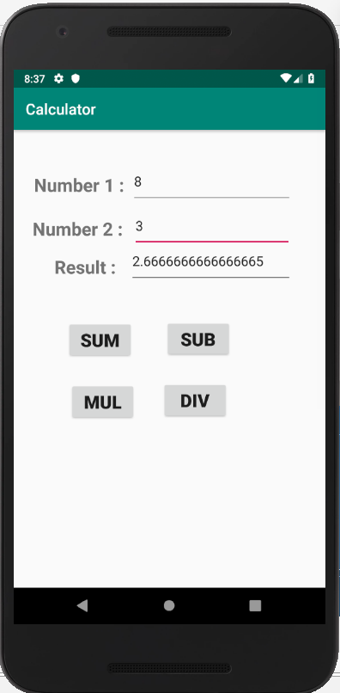

RESULT

The Program has been executed successfully and the output is verified.

Program No.:2
Date :

TO DISPLAY CONTENTS IN ANOTHER PAGE

AIM : A Program to display the details of a student in another page using Intent.
PROCEDURE :

activity_main_intent.xml

<?xml version="1.0" encoding="utf-8"?>
<android.support.constraint.ConstraintLayout xmlns:android="http://schemas.android.com/apk/res/android"
xmlns:app="http://schemas.android.com/apk/res-auto"
xmlns:tools="http://schemas.android.com/tools"
android:layout_width="match_parent"
android:layout_height="match_parent"
tools:context=".MainActivityIntent">
<RelativeLayout
android:layout_width="match_parent"
android:layout_height="match_parent"
android:backgroundTint="@color/colorAccent"
android:background="@drawable/ic_launcher_foreground">
<TextView
android:id="@+id/t1"
android:layout_width="wrap_content"
android:layout_height="wrap_content"
android:layout_alignParentStart="true"
android:layout_alignParentLeft="true"
android:layout_alignParentTop="true"
android:layout_marginStart="12dp"
android:layout_marginLeft="12dp"
android:layout_marginTop="135dp"
android:text="STUDENT ID"
android:textColor="@color/colorPrimaryDark"
android:textSize="18dp"
android:textStyle="bold|italic"
android:typeface="serif"
app:fontFamily="serif" />
<TextView
android:id="@+id/t2"
android:layout_width="wrap_content"
android:layout_height="wrap_content"
android:layout_alignStart="@+id/t1"
android:layout_alignParentTop="true"
android:layout_marginStart="1dp"
android:layout_marginTop="209dp"
android:text="STUDENT NAME"
android:textColor="@color/colorPrimaryDark"
android:textSize="18dp"
android:textStyle="bold|italic"
android:typeface="serif"
app:fontFamily="serif"
android:layout_alignLeft="@+id/t1"
android:layout_marginLeft="1dp" />
<TextView
android:id="@+id/t3"
android:layout_width="wrap_content"
android:layout_height="wrap_content"
android:layout_alignStart="@+id/t1"
android:layout_alignParentBottom="true"
android:layout_marginBottom="209dp"
android:text="SCLASS"
android:textColor="@color/colorPrimaryDark"
android:textSize="18dp"
android:textStyle="bold|italic"
android:typeface="serif"
app:fontFamily="serif"
android:layout_alignLeft="@+id/t1" />

<TextView
android:id="@+id/t4"
android:layout_width="wrap_content"
android:layout_height="wrap_content"
android:layout_alignStart="@+id/t2"
android:layout_alignParentBottom="true"
android:layout_marginBottom="138dp"
android:text="SMARK"
android:textColor="@color/colorPrimaryDark"
android:textSize="18dp"
android:textStyle="bold|italic" />
<EditText
android:id="@+id/e1"
android:layout_width="wrap_content"
android:layout_height="wrap_content"
android:layout_alignParentTop="true"
android:layout_alignParentEnd="true"
android:layout_alignParentRight="true"
android:layout_marginTop="127dp"
android:layout_marginEnd="5dp"
android:layout_marginRight="5dp"
android:ems="10"
android:inputType="textPersonName"
android:textColor="@color/colorPrimaryDark"
android:textSize="18dp"
android:textStyle="bold|italic"
android:typeface="serif" />
<EditText
android:id="@+id/e2"
android:layout_width="wrap_content"
android:layout_height="wrap_content"
android:layout_alignEnd="@+id/e1"
android:layout_alignParentTop="true"
android:layout_marginTop="195dp"
android:layout_marginEnd="-5dp"
android:ems="10"
android:inputType="textPersonName"
android:textColor="@color/colorPrimaryDark"
android:textSize="18dp"
android:textStyle="bold|italic"
android:typeface="serif" />
<EditText
android:id="@+id/e3"
android:layout_width="wrap_content"
android:layout_height="wrap_content"
android:layout_alignEnd="@+id/e1"
android:layout_alignParentBottom="true"
android:layout_marginBottom="200dp"
android:ems="10"
android:inputType="textPersonName"
android:textColor="@color/colorPrimaryDark"
android:textSize="18dp"
android:textStyle="bold|italic"
android:typeface="serif" />
<EditText
android:id="@+id/e4"
android:layout_width="wrap_content"
android:layout_height="wrap_content"
android:layout_alignEnd="@+id/e1"
android:layout_alignParentBottom="true"
android:layout_marginBottom="124dp"

android:ems="10"
android:inputType="textPersonName"
android:textColor="@color/colorPrimaryDark"
android:textSize="18dp"
android:textStyle="bold|italic"
android:typeface="serif" />
<TextView
android:id="@+id/t5"
android:layout_width="wrap_content"
android:layout_height="wrap_content"
android:layout_alignParentTop="true"
android:layout_centerHorizontal="true"
android:layout_marginTop="49dp"
android:text="STUDENT INFORMATION"
android:textColor="@android:color/holo_blue_bright"
android:textSize="24dp"
android:textStyle="bold|italic"
android:typeface="serif"
app:fontFamily="serif" />
<Button
android:id="@+id/b1"
android:layout_width="wrap_content"
android:layout_height="wrap_content"
android:layout_alignParentBottom="true"
android:layout_marginStart="-26dp"
android:layout_marginBottom="45dp"
android:layout_toEndOf="@+id/t1"
android:text="SUBMIT"
android:textColor="?android:attr/colorActivatedHighlight"
android:textSize="18dp"
android:textStyle="bold|italic"
android:typeface="serif" />
<Button
android:id="@+id/b2"
android:layout_width="wrap_content"
android:layout_height="wrap_content"
android:layout_alignBottom="@+id/b1"
android:layout_alignParentEnd="true"
android:layout_alignParentRight="true"
android:layout_marginEnd="94dp"
android:layout_marginRight="94dp"
android:text="RESET"
android:textColor="?android:attr/colorActivatedHighlight"
android:textSize="18dp"
android:textStyle="bold|italic"
android:typeface="serif" />
</RelativeLayout>
</android.support.constraint.ConstraintLayout>
activity_main_intent2.xml
<?xml version="1.0" encoding="utf-8"?>
<RelativeLayout xmlns:android="http://schemas.android.com/apk/res/android"
xmlns:app="http://schemas.android.com/apk/res-auto"
xmlns:tools="http://schemas.android.com/tools"
android:layout_width="match_parent"
android:layout_height="match_parent"
tools:context=".MainActivityIntent2">
<Button
android:id="@+id/button"
android:layout_width="wrap_content"

android:layout_height="wrap_content"
android:layout_alignTop="@+id/button2"
android:layout_alignParentStart="true"
android:layout_alignParentLeft="true"
android:layout_marginStart="63dp"
android:layout_marginLeft="63dp"
android:text="Click"
android:textColor="?android:attr/colorActivatedHighlight"
android:textSize="18dp"
android:textStyle="bold|italic"
android:typeface="serif"
tools:layout_editor_absoluteX="82dp"
tools:layout_editor_absoluteY="377dp" />
<Button
android:id="@+id/button2"
android:layout_width="wrap_content"
android:layout_height="wrap_content"
android:layout_alignParentEnd="true"
android:layout_alignParentRight="true"
android:layout_alignParentBottom="true"
android:layout_marginEnd="85dp"
android:layout_marginRight="85dp"
android:layout_marginBottom="111dp"
android:text="HOME"
android:textColor="?android:attr/colorActivatedHighlight"
android:textSize="18dp"
android:textStyle="bold|italic"
android:typeface="serif"
tools:layout_editor_absoluteX="223dp"
tools:layout_editor_absoluteY="377dp" />
</RelativeLayout>

//Intent MainActivity.java
package com.example.mcet.intent; import android.content.Intent; import android.support.v7.app.AppCompatActivity; import android.os.Bundle; import android.view.View; import android.widget.Button; import android.widget.EditText; import android.widget.TextView; public class MainActivity extends AppCompatActivity { TextView tt1,tt2,tt3; EditText ee1,ee2,ee3,ee4,ee5,ee6; Button bb1; @Override protected void onCreate(Bundle savedInstanceState) { super.onCreate(savedInstanceState); setContentView(R.layout.activity_main); tt1=(TextView)findViewById(R.id.t1); tt2=(TextView)findViewById(R.id.t2); tt3=(TextView)findViewById(R.id.t3); ee1=(EditText)findViewById(R.id.e1); ee2=(EditText)findViewById(R.id.e2); ee3=(EditText)findViewById(R.id.e3); bb1=(Button)findViewById(R.id.b1); bb1.setOnClickListener(new View.OnClickListener() { @Override public void onClick(View v) { String aa=ee1.getText().toString(); String bb=ee2.getText().toString(); String cc=ee3.getText().toString(); Intent i=new Intent(MainActivity.this, Main2Activity.class); i.putExtra("name",aa); i.putExtra("roll",bb); i.putExtra("mark",cc); startActivity(i); } }); } }

//Intent Main2Activity.java
package com.example.mcet.intent; import android.content.Intent; import android.os.Bundle; import android.support.design.widget.FloatingActionButton; import android.support.design.widget.Snackbar; import android.support.v7.app.AppCompatActivity; import android.support.v7.widget.Toolbar; import android.view.View; import android.widget.EditText; import android.widget.TextView; public class Main2Activity extends AppCompatActivity { EditText ee4,ee5,ee6; TextView tt1; @Override
protected void onCreate(Bundle savedInstanceState) { super.onCreate(savedInstanceState); setContentView(R.layout.activity_main2); ee4=(EditText) findViewById(R.id.e4); ee5=(EditText) findViewById(R.id.e5); ee6=(EditText) findViewById(R.id.e6); Intent i=getIntent(); String s=i.getStringExtra("name"); String ss=i.getStringExtra("roll"); String sss=i.getStringExtra("mark"); ee4.setText(s); ee5.setText(ss); ee6.setText(sss); Toolbar toolbar = (Toolbar) findViewById(R.id.toolbar); setSupportActionBar(toolbar); FloatingActionButton fab = (FloatingActionButton) findViewById(R.id.fab); fab.setOnClickListener(new View.OnClickListener() { @Override public void onClick(View view) { Snackbar.make(view, "Replace with your own action", Snackbar.LENGTH_LONG) .setAction("Action", null).show(); } }); } }

OUTPUT

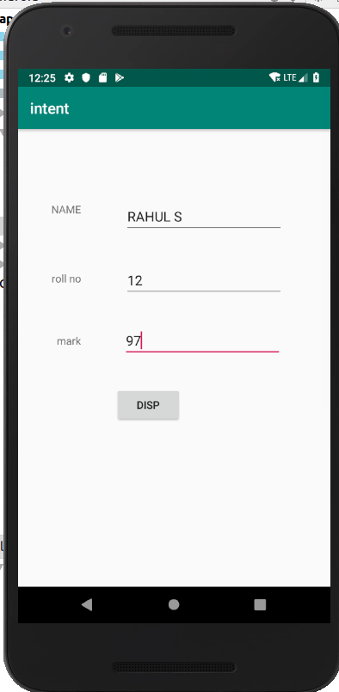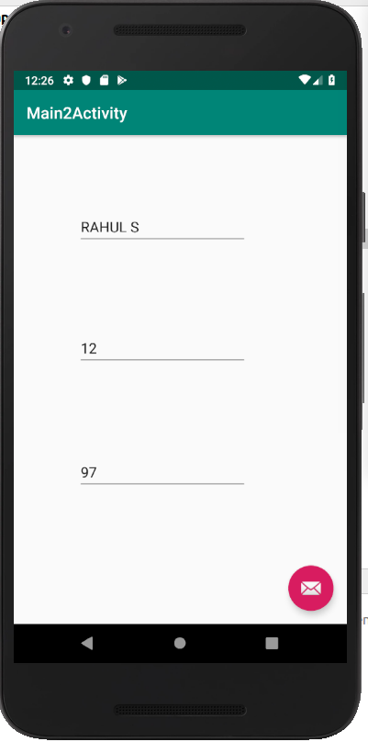

RESULT

The Program has been executed successfully and the output is verified.

